I am reluctantly giving up the bulk of my bagpipe and other instrument collection due to an unfortunate thumb injury that went untreated during COVID causing irreversible damage. I just can’t play for any period of time anymore without extreme discomfort. The following instruments will all be available for sale at the Pipers Gathering. Any unsold instruments will be listed on alternative sites following the Gathering.
Cornish Double Pipes
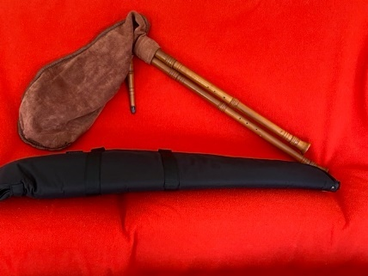
Made by Julian Goodacre, who is no longer making this wonderful instrument. Comes with a soft sided (rifle) case that fits it well. For more information: https://www.goodbagpipes.com/index.php/my-bagpipes/english-bagpipes/cornish-doublepipe
—$1150 (or nearest reasonable offer)
Contact Nan Donald (gaita@comcast.net) or (by text only) at 617-513-7751

Durer Pipes
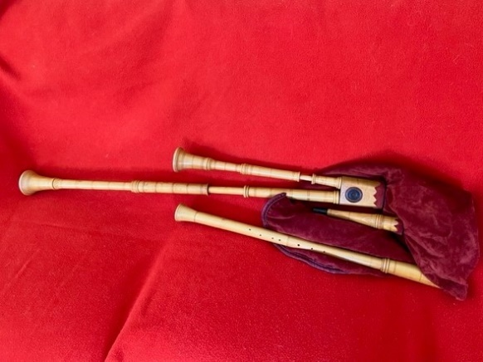
Again, made by Julian Goodacre, who is no longer making this amazing instrument. For more on this instrument from Julian’s website: https://www.goodbagpipes.com/index.php/my-bagpipes/other-bagpipes/durer-pipes
—$1500 (or nearest reasonable offer)
Contact Nan Donald (gaita@comcast.net) or (by text only) at 617-513-7751

Leicestershire Smallpipes with C and D Chanters
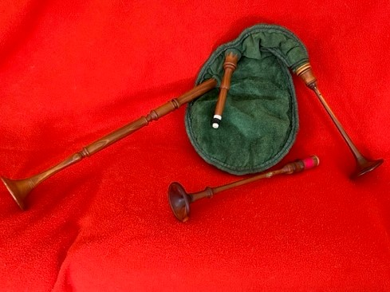
Made by Julian Goodacre, comes with two chanters and a tuning ring for the C chanter.
—$1200 (or nearest reasonable offer)
Contact Nan Donald (gaita@comcast.net) or (by text only) at 617-513-7751

English Great pipes in D
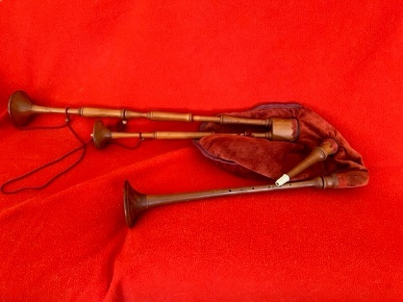
Made by Julian Goodacre, this pipe is no longer in production. This pipe comes with bass and tenor drone. See following link for further information: https://www.goodbagpipes.com/index.php/my-bagpipes/english-bagpipes/english-greatpipe
—$1500 (or nearest reasonable offer)
Contact Nan Donald (gaita@comcast.net) or (by text only) at 617-513-7751

Bohassa
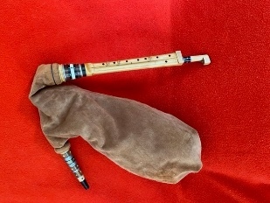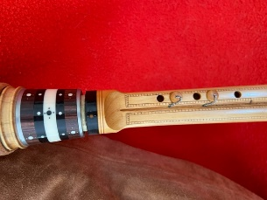
The deeper pitched cousin to the Occitan Boha, made by esteemed luthier Robert Matta. For more info (in French only): (https://www.cornemusesoccitanes.com/bohassa/
—$1300 (or nearest reasonable offer)
Contact Nan Donald (gaita@comcast.net) or (by text only) at 617-513-7751

Bot Aranes
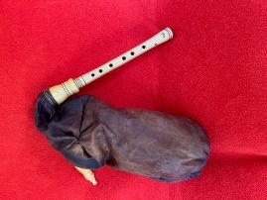
Unusual regional instrument from the Valle d’Aran (Catalunya, Spain), this instrument, made by Catalonian builder Cesc Sans has no drone, but has a wonderful sonorous sound. Like the Boha and Bulgarian bagpipes, the charter reed is a single reed. chanter For a sound sample, see video link below, but note that the player uses a shruti box to provide a drone).
https://www.youtube.com/watch?v=hNbo_ZKHMlc
—$450 (or nearest reasonable offer)
Contact Nan Donald (gaita@comcast.net) or (by text only) at 617-513-7751

Craba (or Bodega)
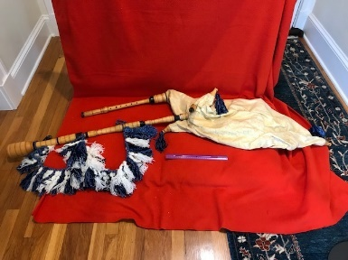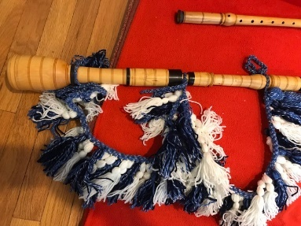
This is the huge, traditional bagpipe from the Montagne Noire located between Mazamet and Carcassonne, in the of Haut-Languedoc) region of France. My craba was made by noted player and builder Pierre Rouch. After the gathering, if not sold, I plan to offer it and my other pipes on other specialty venues.
—$1900 or nearest reasonable offer.
Contact Nan Donald (gaita@comcast.net) or (by text only) at 617-513-7751
_______________________________________________

Italian Piva
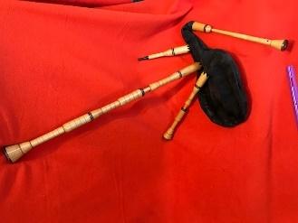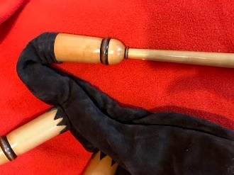
Italian piva in G made by workshop DEIV in 2006. Somewhat chromatic—(F#) G, A, B flat, B,C,D, D#, E, F, F#, G. More info: https://www.deivliutaio.com/1-piva-piemontese/piva-piemontese-2bordone-gb.php
—$900 or nearest reasonable offer.
Contact Nan Donald (gaita@comcast.net) or (by text only) at 617-513-7751
_______________________________________________

Italian Zampogna
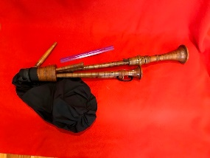
This zampogna (unknown maker in Scapoli) plays in F# with a nice mellow, not too overpowering sound. It has a gortex bag and NOT the dreaded rubber tire bag these instruments frequently come with!
—$550 or nearest reasonable offer.
Contact Nan Donald (gaita@comcast.net) or (by text only) at 617-513-7751

Kaba Gaida (Bulgarian bagpipe)
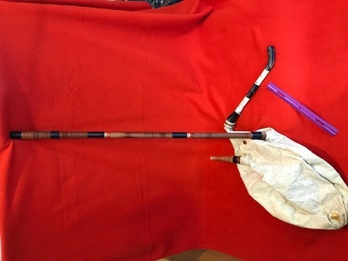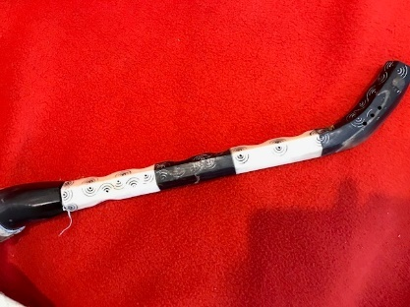
Most typical Bulgarian bagpipe with wonderful deep drone.

—$250 (or nearest reasonable offer)
Contact Nan Donald (gaita@comcast.net) or (by text only) at 617-513-7751

_______________________________________________

Dzhura (or Djura) gaida (Bulgarian bagpipe)
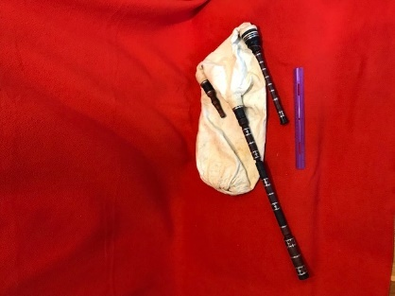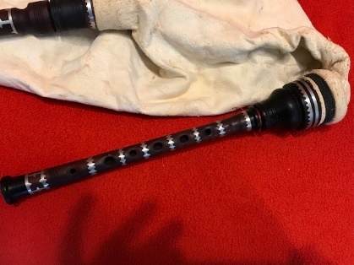
This dzhura gaida by Zdravko Beshendjiev is in G, made of plum wood and has pewter inlay throughout,
—$300 (or nearest reasonable offer)
Contact Nan Donald (gaita@comcast.net) or (by text only) at 617-513-7751

Smallpipes in D
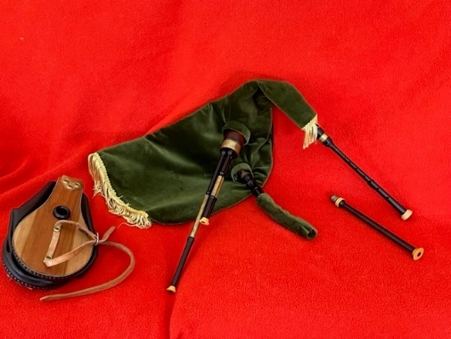
Made by Denny Hall, new chanter by Michael McHarg.
—$600 (or nearest reasonable offer)
Contact Nan Donald (gaita@comcast.net) or (by text only) at 617-513-7751

Bohemian Bok by Toru Sonada
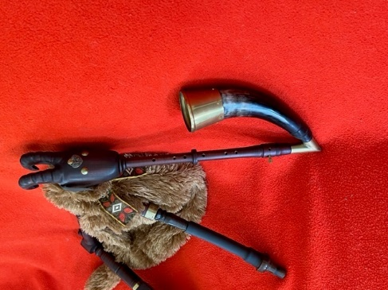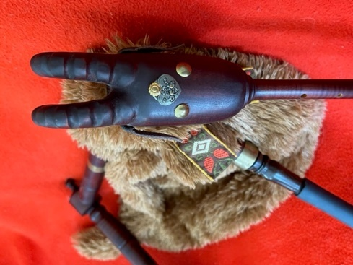
Bock pipes ("Dudy" in Czech) are traditional bagpipes of Czech, Southern Germany and Austria, having a single reed in the chanter. Comes with both original and upgraded bellows.
—$1300 (or nearest reasonable offer)
Contact Nan Donald (gaita@comcast.net) or (by text only) at 617-513-7751

Cuatro
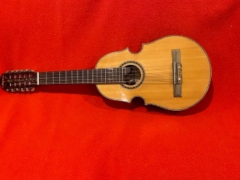
Puerto Rican Cuatro by Antares, comes with a hard shell fitted case and instructional materials.
—$275 (or nearest reasonable offer)
Contact Nan Donald (gaita@comcast.net) or (by text only) at 617-513-7751

Bandurria
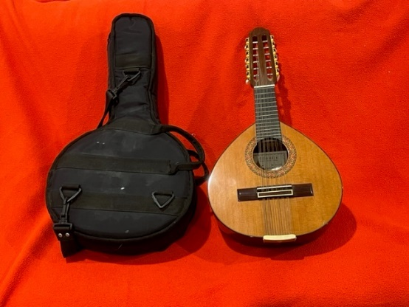
Spanish instrument that started the mandolin craze in the US back around 100 years ago….
—$300 (or nearest reasonable offer)
Contact Nan Donald (gaita@comcast.net) or (by text only) at 617-513-7751

